|  |  |
| --- | --- |
| This is your chance to be creative and program some cool enhancements for the I Have a Dream app.  **Objectives:** In this lesson you will:   * continue learning to navigate the App Inventor programming platform; * deepen your understanding of event-driven programming. | UIShot.PNG |

# Getting Ready

1. Open [App Inventor 2](http://ai2.appinventor.mit.edu/).
2. Go to *Project* and select the I Have A Dream app that you created in the first tutorial.

# I Have a Dream Projects

## Projects

Here are some creative projects. Complete all of the mini-projects. To save your I Have A Dream project, do a “Save As” to rename your project to “IHaveADream#” [where # will be replaced by the mini project number you will complete from the list of mini projects below.]

1. The Sound component can also vibrate the phone. Add this feature to your app’s *When Button1 Click* procedure. (Hint: Search in the Blocks Editor.)

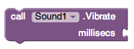

1. Instead of playing Malcolm X’s speech, you can have it “speak” some text of your own. For this you’ll need a new component. Fortunately, App Inventor has a *TextToSpeech* component that’s perfect. (Hint: Search the Designer Palette to find the TextToSpeechcomponent and then modify the blocks to use the component.)

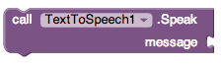

1. Instead of using a Button click event to play Malcolm X’s speech, have it play when the phone is shaken. (Hint: For this you’ll need to use the *Accelerometer Sensor* and respond to its *Shaking* event.)

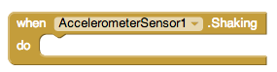

1. Change your apps home screen icon to be something unique that reflects your app, rather than the default app inventor logo. This will make your apps look more professional. You can find the place to change the default app icon in the *Screen1* properties box.

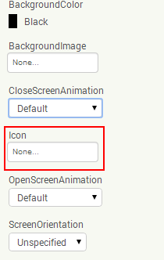

1. **Challenging:** Create your own Soundboard app with at least three pictures and three sound files that are played when you click the pictures. Remember to write down your ideas in *pseudocode* before you begin coding.

***Nice work! Complete the Self-Check Exercises and Portfolio Reflection Questions as directed by your instructor.***